Week 1 :

Explain the following questions in two simple sentences

1. What is the use of the git add command?

Ans. The git add command adds changes in the working directory to the staging area. It prepares the changes to be committed to the repository. We add multiple files as well in one go with (git add .)

1. Write the command to create a branch “feature-login”

Ans. git branch feature-login

1. What is a pull request? Write the steps involved in creating a pull request.

Ans. A pull request is a way to propose changes to a repository. To create a pull request:

* Push your branch to the repository by “git push origin your-branch-name”
* Navigate to the repository on GitHub.
* Click "New pull request."
* Select your branch and compare it with the main branch.
* Click "Create pull request" and provide a title and description.
* Submit the pull request.

1. How do you add collaborators?

Ans. To add collaborators, go to the repository on GitHub, click on "Settings," select "Manage access," and then invite collaborators by entering their GitHub username or email.

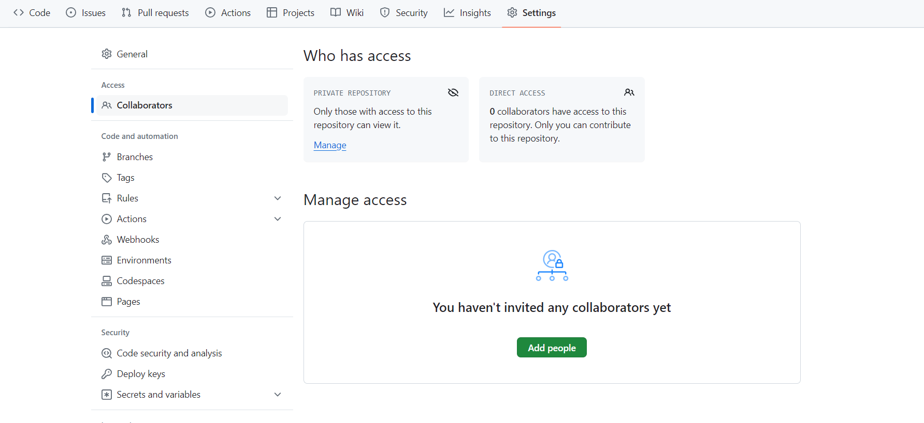

1. What is the command used to commit our changes in github repo?

Ans. git commit -m "My Changes"

1. Create a github account and repository to save all your assignment tasks. Example repository name: rg-assignments

Ans. <https://github.com/PrakharDhyani/RG-Assignments>

1. Create a branch called feature-java(you can use it later to push all your java related tasks to this branch)

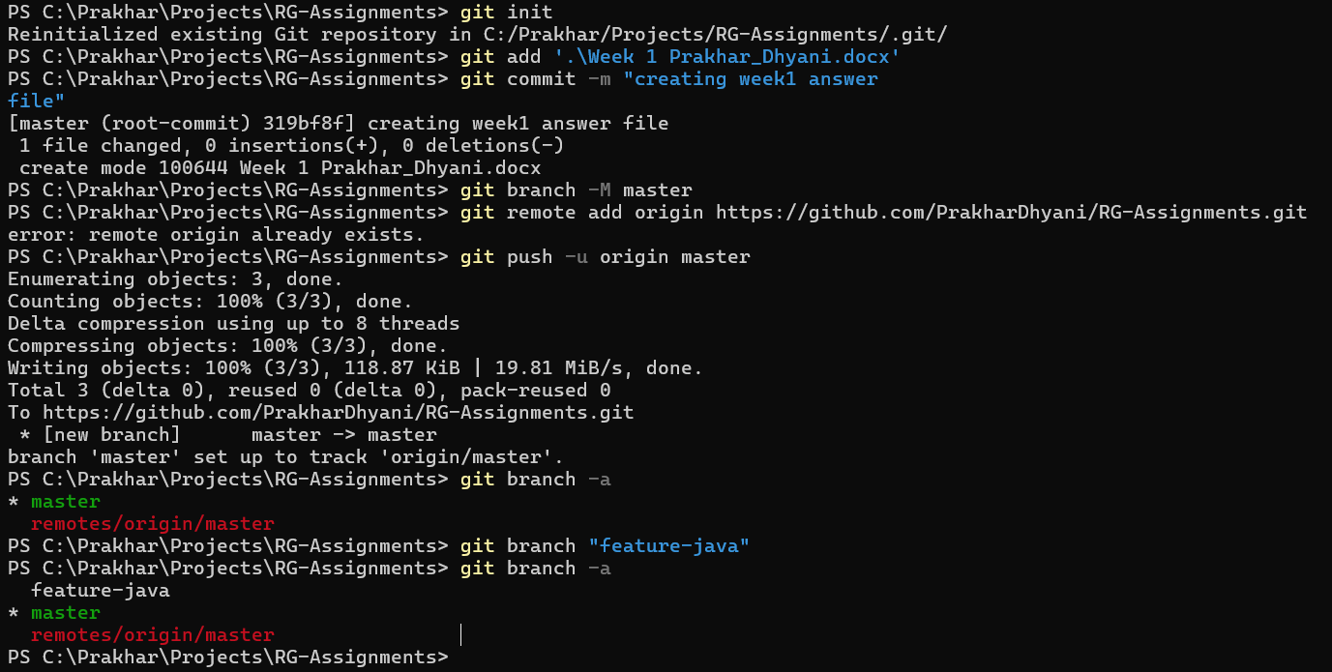

1. Install IntelliJ IDE. Create a simple java project displaying “Hello World!!”and share the screenshot.

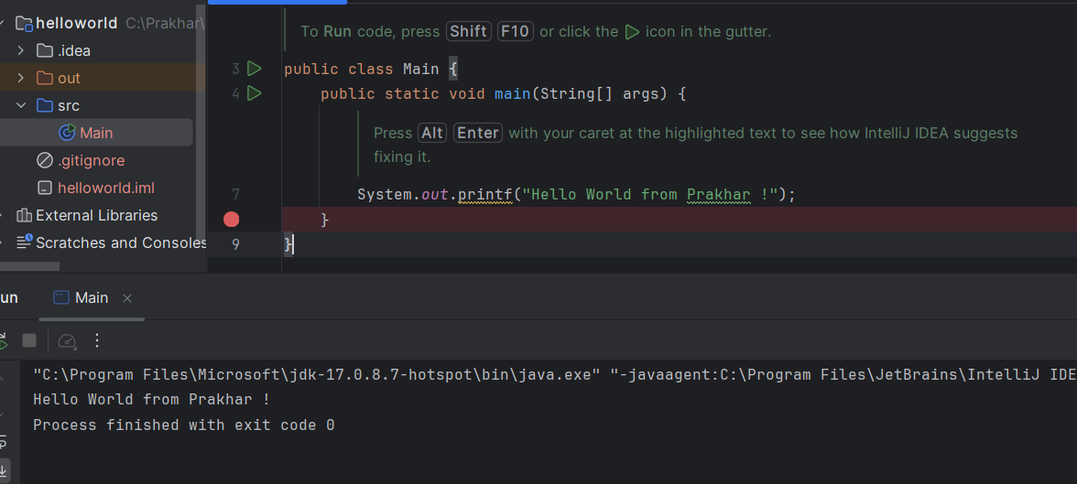

1. In IntelliJ IDE, explore the shortcut keys for the following
   1. To run the project – shift + F10
   2. To select a line – ctrl + w
   3. To comment/uncomment a line – ctrl + /
   4. To delete a line – ctrl + y